**Docker Hands-On:**

**Dockerfile to deploy and run application in tomcat**:

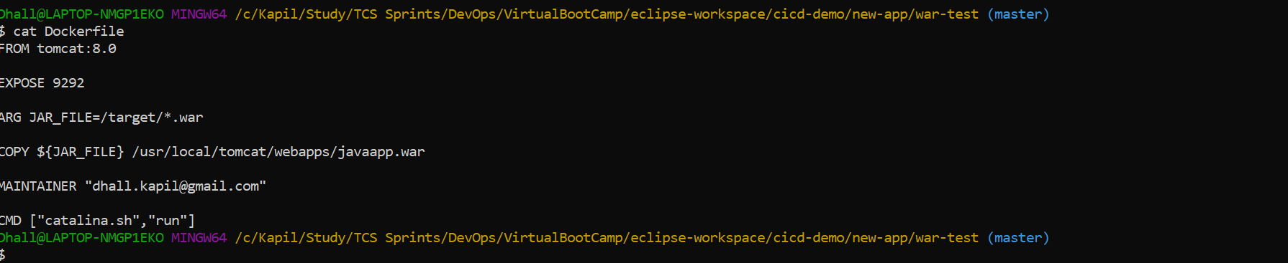

**Running the application using dockerfile in a tomcat container:**

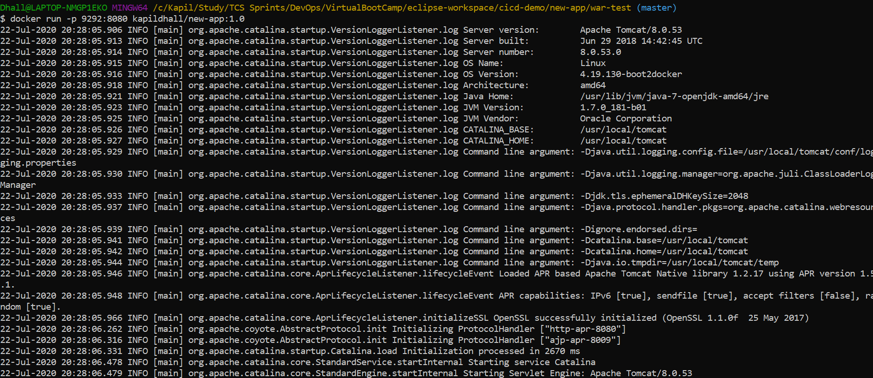

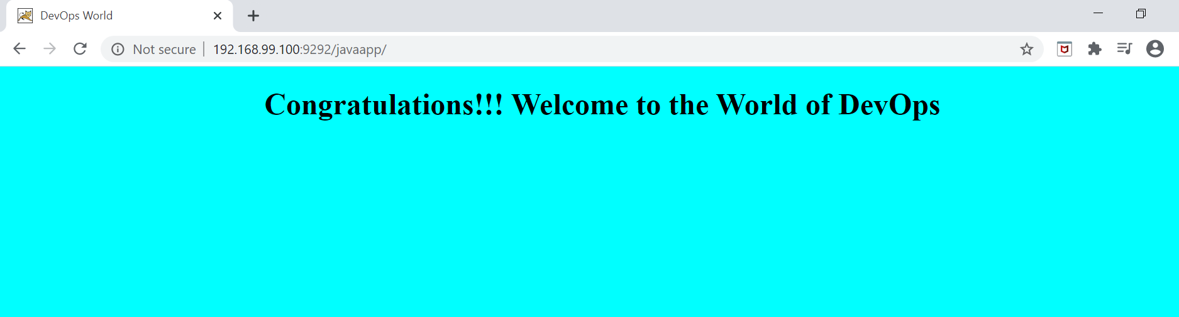

**Running application and mysql using docker-compose.yml:**

docker-compose.yml:

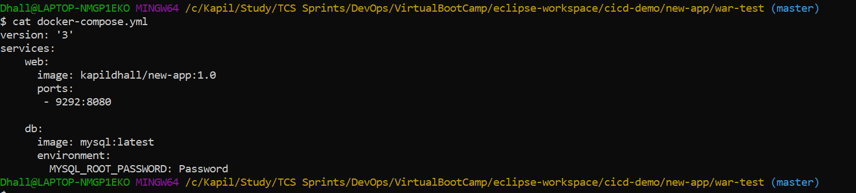

Run the docker-compose:

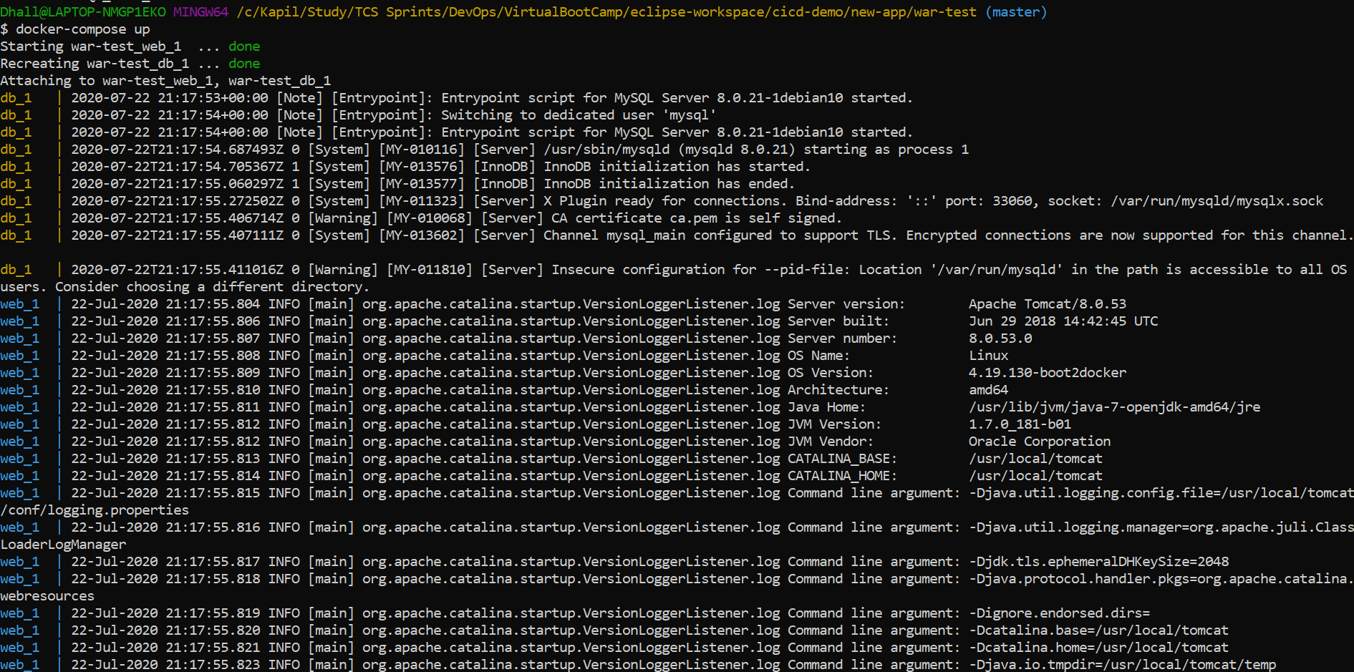

Verify both application: mysql and java application is running:



